**IC TESTER USING MATLAB**

*Kiruthika K1,Bhumika K Ramesh2,Vishal G3,Vivek N4,Jyoti5*

*1 Assistant professor, Rajarajeswari College of Engineering, Bengaluru-Karnataka, 560074, India*

*2Engineering student, Rajarajeswari College of Engineering, Bengaluru-Karnataka, 560074, India*

*3Engineering student, Rajarajeswari College of Engineering, Bengaluru-Karnataka, 560074, India*

*4 Engineering student, Rajarajeswari College of Engineering, Bengaluru-Karnataka, 560074, India*

*5.Engineering student, Rajarajeswari College of Engineering, Bengaluru-Karnataka, 560074, India*

*Emails: kiruthi.km21@gmail.com1, bhumikaramesh2017@gmail.com2,bhumikaramesh2017@gmail.com2*

**Abstract**

Abstracts with no more than 250 words should be supplied to reflect the content of the paper. A concise and factual abstract is required. The abstract should state briefly the context of the problem (background), the purpose/aim of the research, the principal methods, the results and major conclusion (contribution). An abstract is often presented separately from the article, so it must be able to stand-alone. For this reason, References/citation should be avoided. Also, non-standard or uncommon abbreviations should be avoided, but if essential they must be defined at their first mention in the abstract itself. Use Times New Roman font style for entire template.

**Keywords:**Alphabetically sorted; Capitalized first word; From A to Z; Maximum 5 keywords; Sentence case; Separate by semicolon (;) between keyword

1. **INTRODUCTION (12 pt)**

Provide an adequate background, context of the problems based on the literature review. State the objectives of the work and emphasize the originality (state of the art). Citation more than one cited article/reference should be written in order by year (Birari, H *et al*., 2023; Rajan, P, 2023;).

The Introduction presents the purpose of the studies reported and their relationship to earlier work in the field. It should not be an extensive review of the literature. Use only those references required to provide the most salient background to allow the readers to understand and evaluate the purpose and results of the present study without referring to previous publications on the topic.[2]

The Introduction presents the purpose of the studies reported and their relationship to earlier work in the field. It should not be an extensive review of the literature. Use only those references required to provide the most salient background to allow the readers to understand and evaluate the purpose and results of the present study without referring to previous publications on the topic.[1-4]

The Introduction presents the purpose of the studies reported and their relationship to earlier work in the field. It should not be an extensive review of the

literature. Use only those references required to provide the most salient background to allow the readers to understand and evaluate the purpose and results of the present study without referring to previous publications on the topic.[2&3]

* 1. **Sub section 1 (12 pt)**

Sub section 1 Sub section 1 Sub section 1 Sub section 1 Sub section 1 Sub section 1 Sub section 1 Sub section 1 Sub section 1 Sub section 1 Sub section 1 Sub section 1 Sub section 1 Sub section 1 Sub section 1 Sub section 1.

* 1. **Sub section 2 (12 pt)**

Sub section 2 Sub section 2 Sub section 2 Sub section 2 Sub section 2 Sub section 2 Sub section 2 Sub section 2 Sub section 2 Sub section 2 Sub section 2 Sub section 2 Sub section 2 Sub section 2 Sub section 2 Sub section 2 Sub section 2 Sub section 2 Sub section 2 Sub section 2 Sub section 2 Sub section 2 Sub section 2 Sub section 2 Sub section 2.

1. **METHOD (12 pt)**

The Methods sections should be brief, but they should include sufficient technical information to allow the experiments to be repeated by a qualified reader. Only new methods should be described in detail. Cite previously published procedures in References.

Tables and Figures are presented center, as shown below and cited in the manuscript.

**Table 1.** Experimental input parameters for EDM

|  |  |  |
| --- | --- | --- |
| EDM TOOL | VOLTAGE  (v) | PULSE ON(µs) |
| Aluminum | 11 | 12 |
| Copper | 22 | 44 |
| Graphite | 33 | 10 |
| Composite | 45 | 66 |
| Aluminum | 11 | 12 |
| Copper | 22 | 44 |
| Graphite | 33 | 10 |
| Composite | 45 | 66 |
| Aluminum | 11 | 12 |
| Copper | 22 | 44 |
| Graphite | 33 | 10 |
| Composite | 45 | 66 |

* 1. **Tables**

Tables should be typewritten separately from the main text and preferably in an appropriate font size to fit each table on a separate page. Each table must be numbered with Arabic numerals (e.g., Table 1, Table 2) and include a title. Place footnotes to tables below the table body and indicate them with superscript lowercase letters (a, b, c, etc.), not symbols. Do not use vertical rulings in the tables. Each column in a table must have a heading, and abbreviations, when necessary, should be defined in the footnotes.

* 1. **Figures**

Figures should be provided separately from the main text. Use Arabic numerals to number all figures (e.g., Figure 1, Figure 2) according to their sequence in the text. The figure number must appear well outside the boundaries of the image itself. Multipart figures should be indicated with uppercase and bold font letters (A, B, C, etc.) without parenthesis, both on the figure itself and in the figure legends**.**

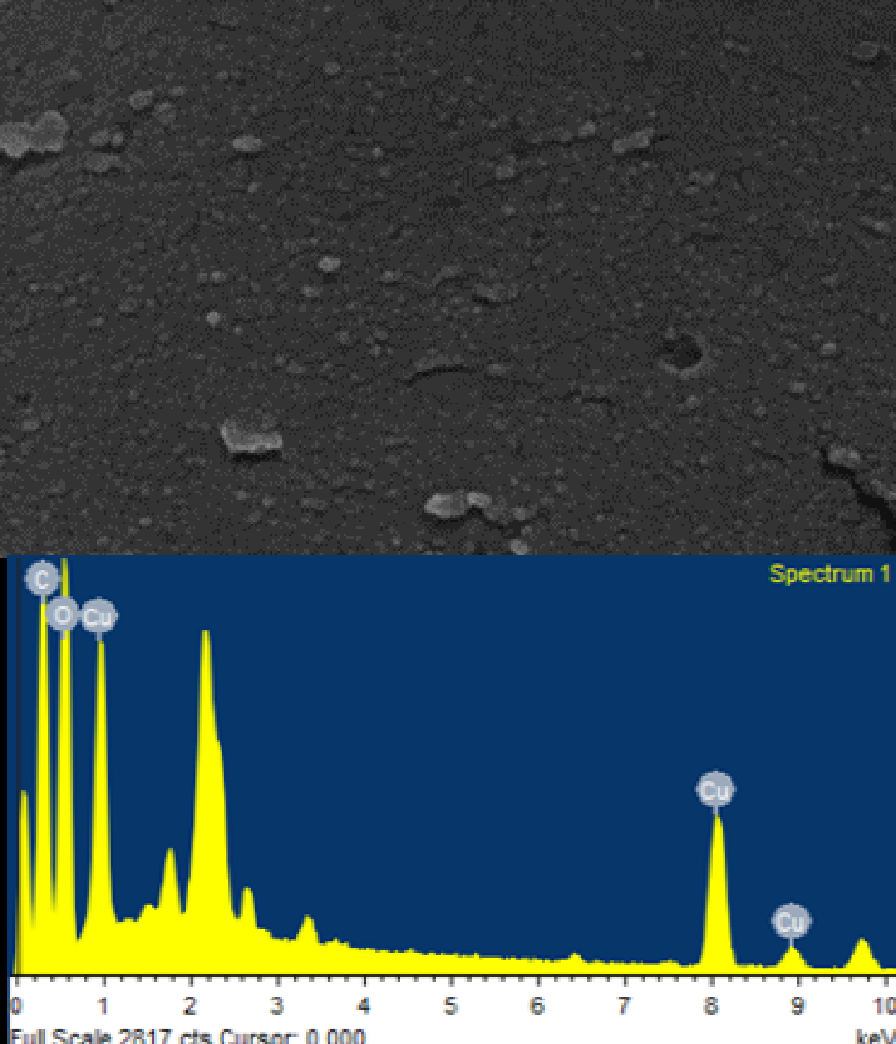

**FIGURE 1.** SEM and EDX visualization of the

synthesized copper nanoparticles [2]

1. **RESULTS AND DISCUSSION (12 pt)**
   1. **Results (12 pt)**

The Results should include the rationale or design of the experiments as well as the results of the experiments. Results can be presented in figures, tables, and text. The Results should include the rationale or design of the experiments as well as the results of the experiments. Results can be presented in figures, tables, and text.

* 1. **Discussion (12 pt)**

The Discussion should be an interpretation of the results rather than a repetition of the Results. The Discussion should be an interpretation of the results rather than a repetition of the Results. The Discussion should be an interpretation of the results rather than a repetition of the Results. The Discussion should be an interpretation of the results rather than a repetition of the Results. The Discussion should be an interpretation of the results rather than a repetition of the Results.

The Discussion should be an interpretation of the results rather than a repetition of the Results. The Discussion should be an interpretation of the results rather than a repetition of the Results. The Discussion should be an interpretation of the results rather than a repetition of the Results.

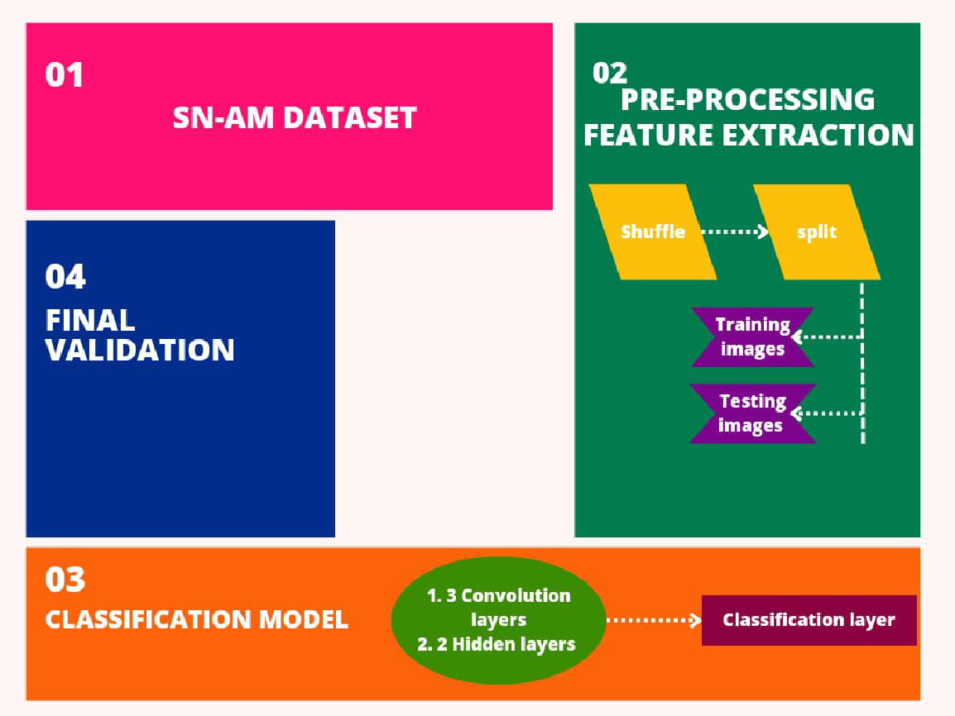

**FIGURE 2.** Process of the dataset [3]

**CONCLUSION (12 pt)**

The Conclusion should contain the confirmation of the problem that has been analyzed in result and discussion section. The Conclusion should contain the confirmation of the problem that has been analyzed in result and discussion section. The Conclusion should contain the confirmation of the problem that has been analyzed in result and discussion section.

**ACKNOWLEDGEMENTS (12 pt)**

Place Acknowledgments, including information on the source of any financial support received for the work being published. Place Acknowledgments, including information on the source of any financial support received for the work being published.

**REFERENCES (12 pt)**

The References section must include all relevant published works, and all listed references must be cited in the text. References should be written in the order of they appear in the text. Within the text, cite listed references use APA style, by their author last name and year (e.g., husnussalam (2010). The author(s) must check the accuracy of all cite listed reference, as the irjaeh Journal will not be responsible for incorrect in-text reference citations. International Research Journal on Advanced Engineering Hub (IRJAEH) adopts APA (American Psychological Association) for reference and citation in text. Authors can use various software to make it easier. All submitted papers in irjaeh Journal are suggested using Reference management applications such as Mendeley, Zotero or EndNote

**Journal reference style:**

1. Birari, H. P., lohar, G. V., & Joshi, S. L. (2023). Advancements in Machine Vision for Automated Inspection of Assembly Parts: A Comprehensive Review. *International Research Journal on Advanced Science Hub*, *5*(10), 365-371. doi: 10.47392/IRJASH.2023.065.
2. Rajan, P., Devi, A., B, A., Dusthackeer, A., & Iyer, P. (2023). A Green perspective on the ability of nanomedicine to inhibit tuberculosis and lung cancer. *International Research Journal on Advanced Science Hub*, *5*(11), 389-396. doi: 10.47392/IRJASH.2023.071.
3. Keerthivasan S P, and Saranya N . “Acute Leukemia Detection using Deep Learning Techniques.” International Research Journal on Advanced Science Hub 05.10 October (2023): 372–381. 10. 47392/IRJASH.2023.066

References to papers accepted for publication but not yet published should show the journal name, the probable year of publication (if known), and they should state "in press."